**Asset Eater – How to Use**

To use Asset Eater, open DoubleClick and navigate to a directory containing the assets you would like to download. E.G.:

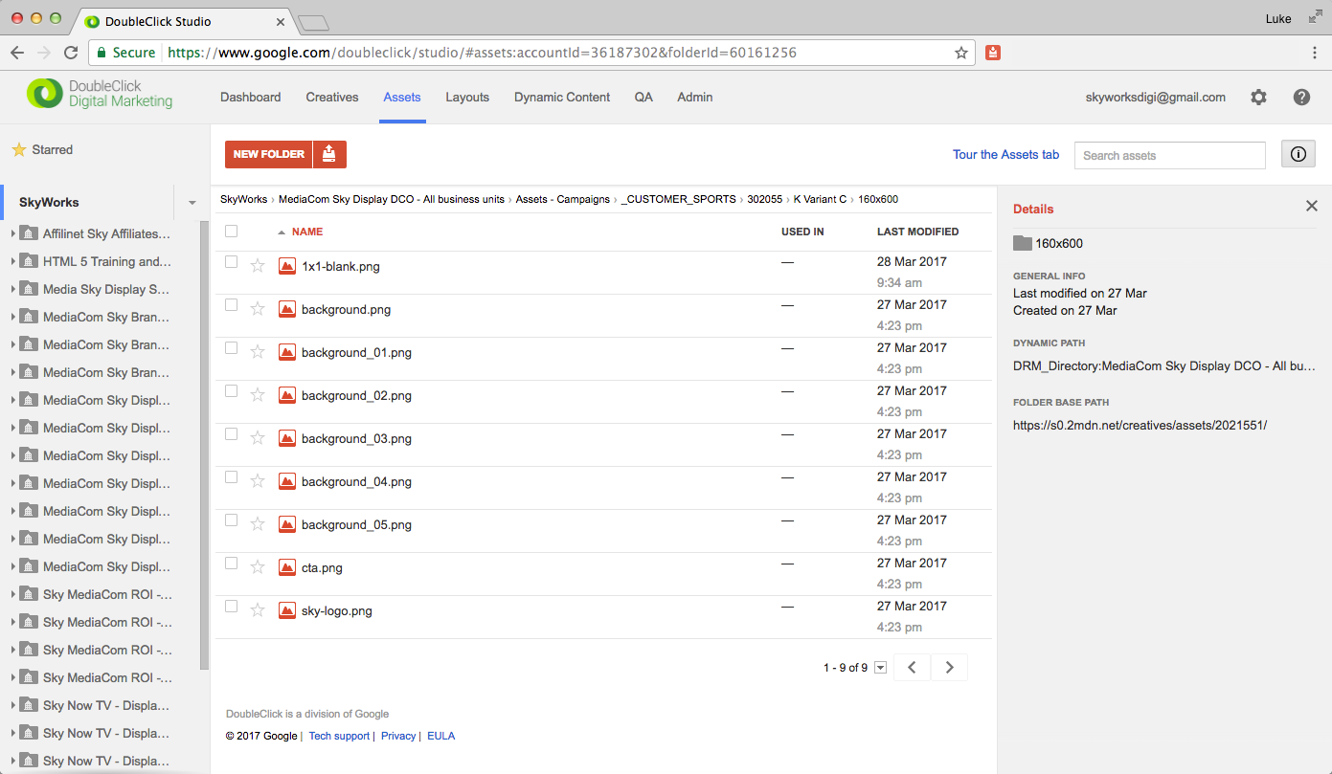

Click on the Asset Eater icon in the Chrome toolbar, which will automatically download all of the assets on screen. The assets will be placed in your default downloads folder; in a sub-directory matching the one you’re currently viewing.

**Note** – If there is more than one page of assets, you will need to click the icon on every page.

­­­